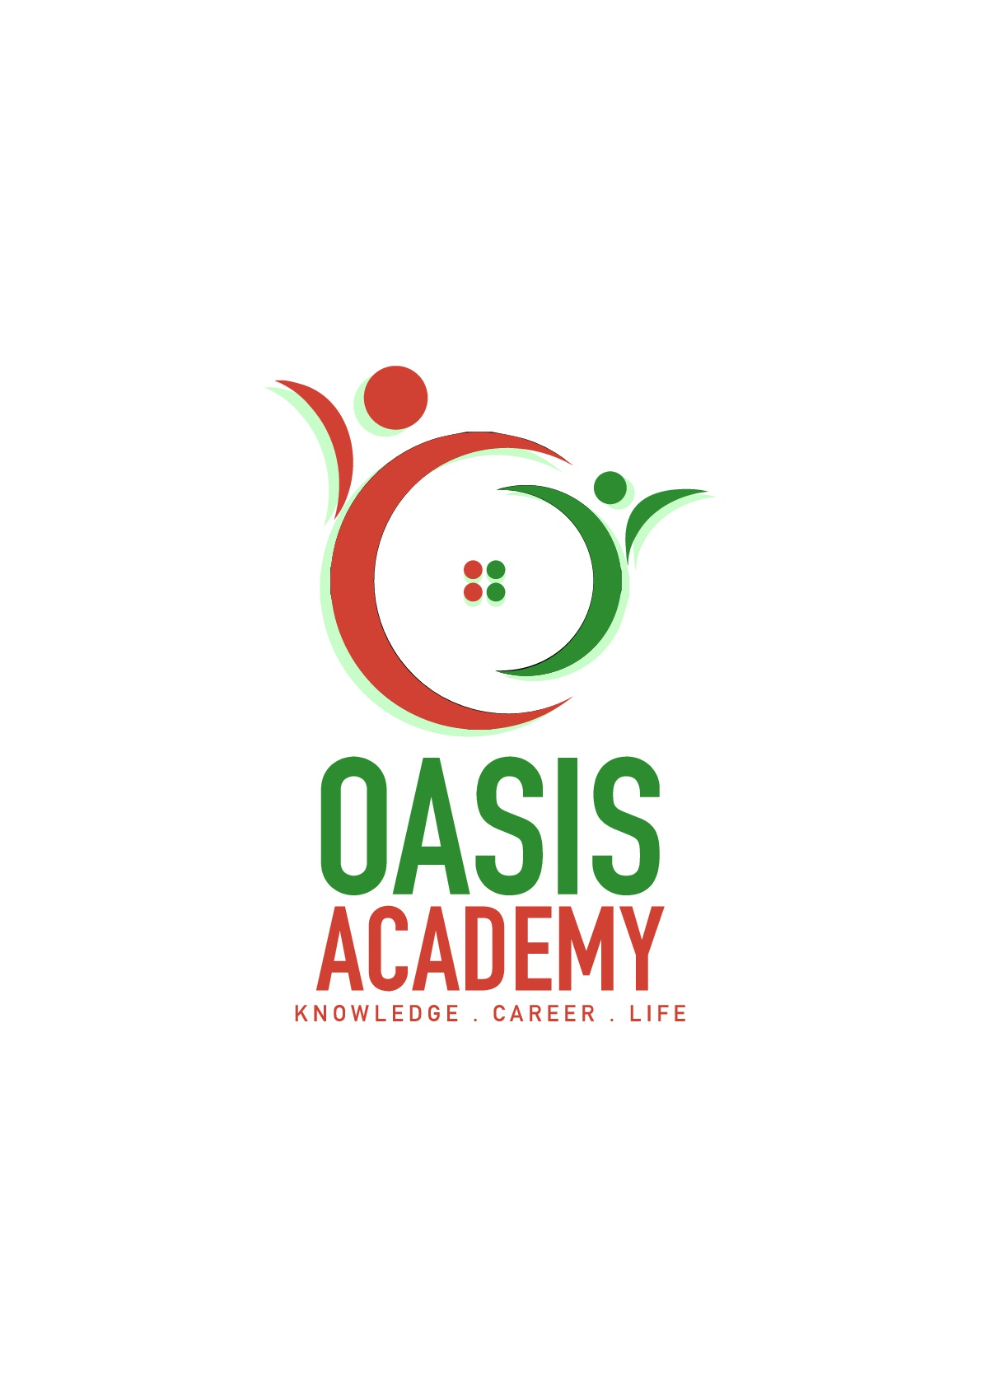

Name: **SHOBANA THAMIL SELVAM**

Login ID: **R03412924@oasis-portal.my**

Course title: **TOURISM AND HOSPITALITY**

Subject Code: **BH04**

Submitted date :11/9/2017

**Table of Contents**

|  |  |  |
| --- | --- | --- |
| **No** | **Details** | **Page** |
| 1 | Executive Summary | 2 |
| 2 | Introduction | 3 |
| 3 | Assignment Question |  |
|  | Part 1 | 4-5 |
|  | Part 2 | 6-11 |
|  | Part 3 | 12-16 |
|  | Part 4 | 17-20 |
| 4 | Conclusion | 21 |
| 5 | References | 22 |
| 6 | Appendix | 23-24 |

**Executive Summary**

In this part of assignment, I will give a brief introduction about what is tourism and hospitality. Tourism and hospitality is consist of travel and tourism, resorts recreation and so on. Its largest employment rate in a country. In first part of the paper of the question, I will give a brief the definition of tourism and also definition of hospitality. Moreover, I will explain about hospitality industry. The second part of the question, I will describe different type of tourism in categories in more details. In the third part of question, I will brief the concept of lodging accommondation and also explain type of hotel accommondation. In last question. I will a significant of entertainment in hospitality management.

**Introduction**

Tourism and hospitality management is a rapidly expanding industry all over the world. In some countries like France, German, Switzerland and Bhutan, tourism and hospitality industry account for the majority of GDP of those countries. With the increasing easiness of global movement, tourist are no more moving around their own countries, but also flying to distant countries with an intention to visit historical location, naturally beautiful and attractive destination, and for many other reason. As per the experts, tourism and hospitality management is a multidisciplinary field whereby are prepared to handle various aspects of this industry like, tourism, preparation and distribution of food, accommondation management for the tourist and many more, etc.

**Assignment Questions**

**Question 1**

**Define the Tourism and Hospitality. Explain your understanding about Hospitality industry.**

Tourism is the temporary, short-term movement of people to destination outside the places where they normally live and work and their activities during the stay at each destination. It include movement for all. It’s a collection of activities. services and industries that delivers travel experience, including transportation, accommondation, eating and drinking establishments, retail shops, entertainments businesses, activity facilities and other hospitality services provided for individuals or groups traveling away from home.

Hospitality professional generally work in administrative or management positions in a service-based environment, and they are responsible for overseeing the operation and success of establish, such as a hotel or restaurant. Hospitality professional also distribute funds, set room rates, and ensure that the service standards of the business are met. General duties for hospitality professional vary depending on the size of the business and the amount of staff available. In large operations, there is usually a hierarchy of general managers, assistant managers, and supervisors who to perform operation tasks relating to their areas of expensive. In a smaller business, the hospitality professional performs these tasks directly.

The industry of providing customer service to travelers or strangers. Hospitality professionals generally work in administrative or management position in a service-based environment, and they are responsible for overseeing the operations and success of an establishment, such as a hotel or restaurant. The hospitality and tourism industry is diverse, and includes many locations including RV parks, food establishments, recreational facilities, campgrounds, boardinghouses and youth hostels. While the overall goal of a hospitality professional is to ensure that guests and customers have pleasurable experiences, they can also be responsible for operations, such as hiring and training new staff; supervising office and financial administration; housekeeping, maintenance, and security staff; and marketing.

The hospitality industry is much border than most other industries. The majority of business niches are composed of only a handful of different businesses, but this industry applies to nearly any company that is focused on customer satisfaction and meeting leisurely needs rather than basic ones. While this industry is very broad, there are some defining aspects that are some defining aspects that are important to understand. One of the fastest growing sectors of the economy of our time today. Diverse enough for people to work in different areas of interest and still be employed within the industry.

**Question 2**

**Brief on different type Tourism categories. Define Tourism.**

Tourism is one of the most flourishing industries in the world, making a significant contribution to world’s GDP. Every year, millions of people from across the globe travel miles and miles away from their homes, in order to see the distant lands and experience their culture. The tourism industry exists in some form or the other in every part of the world, and tourist are seen traveling to some of the seemingly most inaccessible place. The tourism infrastructure has also developed to a great extent over the years, thus, making, it possible to reach and explain the difficult parts of the world. And also, travelling is the one effective way to see the world, experience new cultures and meet new people at the same time. For many tourist, however, traveling accomplished many others purpose that don’t even have anything to do with the joy of visiting a new place. This is why there are many different types of tourism that explain why tourists choose a particular destination and the things that they expect to do when they are there.

Perhaps the most common type of tourist is what most people associate with traveling:

**Adventure Tourism**

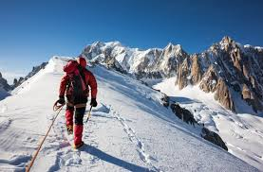

Also known as adventure travel, this kind of tourism is becoming very famous amongst adventure seekers, who are always in the quest of something new to satisfy their adrenaline rush. Adventure tourism requires that a tourist has the heart to take risks and possesses special training and skills. Generally, adventure tourists indulge in difficult activities and extreme sports, such as mountaineering, desert hiking, bungee jumping, scuba diving, paragliding, zip lining, rock climbing and so on. Example of famous destinations are Nepal for mountaineering, Croatia for rock climbing and mountain biking, New Zealand for snowboarding, and etc.

**Business Tourism**



The World Tourism Organization (WTO) gives a definition of tourist that is in contrast to the one given by the AIEST. While the AIEST doesn’t not involve people connected with any sort of activity involving income, the WTO thinks otherwise According to them, “tourism comprises the activities of persons traveling to, and staying in places outside their usual environment for not more than one consecutive year for leisure, business and other purposes,” Common activities involved in business tourism include attending meeting, conferences, and seminars, visiting exhibitions and trade fairs, and so on. Example of quick fact are generally a business tourist is considered to be wealthiest than a leisure tourist, and is believed to have much more purchasing powder.

**Cultural Tourism**

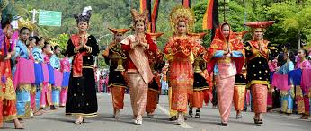

Also known as cultural tourism, this kind of tourism involves the culture of a particular country or region. The concept of cultural tourism encompasses thing, such as history of a given region, the lifestyle of people in a particular geographical locale, architecture, oral traditions, religions, festivals, cuisine, and so on. Activities of cultural tourism in the urban areas may involve visiting museums, theaters, art galleries, and so on; those in the rural areas may involve visiting indigenous cultural communities and having an insight into their traditional, lifestyle, and values. It also involves pop-culture tourism as one of its major subsets, which includes traveling to places, appearing in literary works, TV series, and cinema. Example of sites are the Louvre, Paris, France, Colosseum, Rome, Italy, the Taj Mahal, Agra, India and etc.

**Ecotourism**

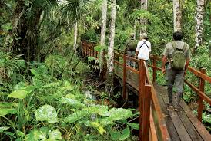

Ecotourism is a very broad category of tourism that involves a socially responsible travel to virtually undisturbed and pristine areas of natural beauty. It involves travelling to places, the primary attractions of which are flora and fauna, natural and/or artificial landform, and settlements of indigenous communities. Ecotourism also encompasses the concepts of geotourism and wildlife tourism. Moreover, agritourism has been added to the list of subtypes of subtypes of ecotourism, which involves visiting a farm or ranch, and indulging in agriculture-related activities. Example of famous destinations are Palau, Micronesia, Norwegian fjords (different location), Norway, Masai Mara National Reserve Kenya and etc.

**Medical Tourism**



The term medical tourism constitutes the travel of patients from one place to the other in order to acquire proper medical care and treatment. Common treatments that patients indulging in medical tourism seek include treatments or certain genetic disorders and specialized surgeries such as joint replacement, cosmetic surgeries, and so on. Some people also travel to seek psychiatric and alternative healing treatments. Suicide tourism is a subset of medical tourism in which patients suffering from incurable ailments travel to other nations euthanasia is legal. Example of famous destinations are United Arab Emirates, Turks and Caicos Island, Turkey, and etc.

**Religious Tourism**

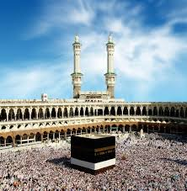

Often referred to as faith tourism, this is a type of tourism where people embark on long journey, either individually or in group, for the purpose of pilgrimage or for caring out missionary activities. Numerous holy places around the world have been developed into thriving tourist centers, and each year, these receive an overwhelming influx of tourist. Places such as temples, churches, mosques, or landforms with religious significance are some of the most visited sites by the religious tourists, who claim to seek onesness with the God through such journeys. Example of famous sites are Varanasi, India, Jerusalem, Israel, Mecca, Saudi Arabia, and etc.

**Sports Tourism**

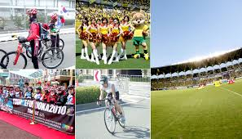

Sports tourism, as the name suggests, involves sport(s) and the excitement and enjoyment it offers, as its basis. It can be either active or passive in nature, which means that one can either travel to another place in order to participate in a sport, or just to watch it being played. Numerous sports, such as cricket, football, tennis, and etc have gained worldwide popularity today, and we see a large number of tours organized at times of major tournaments, which enable people to watch these games live in the stadiums. This niche of tourism generates a good amount of income each year. Example of famous destinations are Brazil, Itali, England, and etc.

**Wellness Tourism**



Wellness tourism is a fast-growing trend in the tourism sector that refers to traveling for the purpose of maintaining and enhancing one’s body, mind, and soul. This kind of tourism involves wellness solutions, such as massages, body treatments, weight loss programs, beauty treatments, and so on. Owing to the popularity of the trend, several destination spas have come up at various places, which offer numerous facilities for tourist according to their likes and preferences. Examples of famous destinations are China, Jordan, Cayman Island, and etc.

**Question 3**

**Describe the lodging accommondation and types of Hotel accommondation.**

**Lodging accommondation**

Lodging is an inclusive term that defines the different types of accommondaton available to a traveler. Lodging may vary in each country but due to globalization most lodging today are standardized with international services. This sector of the hospitality industry features a gamut from luxurious hotels to lavish resorts and campground. Accommondation is an absolutely broad sector of the hospitality industry, ranging from bed & breakfast enterprises and hotels to other facilities that offer lodging services. Again, customer service is indispensable in providing accommondation services. And that isn’t all-efficiency, integrate comfort, and world- class amenities are also its foundation. An extravagant resort, for instance, should offer its customers privacy and services to cut it in the niche. Lodging, also known as accommondation, is a place to sleep for one or more nights. A business in the lodging industry is a business that provides a place for people to sleep overnight. It can be one of many sleeping places such as a fancy hotel, an elder hostel, a campground, or highway side motel. Lodging means accommondation for a period or a place to sleep for one or more night. Fancy hotel. Youth hostel, elder hostels, campground, motel and other business that provide a place for people to sleep overnight are all in the lodging industry. Lodging businesses markets to other market segments such as business travelers, leisure travelers, long-stay travelers, budget travelers, and special travelers like people working with the government, airlines and military.

**Types of hotel accommondation**

* **Conference Hotel**

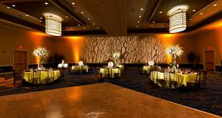

Conference hotel have conference centers attached to their main hotel to cash in on a lucrative conference business. These hotels are geared for group check-ins and introduce efficient registration and meal venues to cope with volume conference participants. The conference annexes will have independent entrance and large parking lots. Some conference hotel may also include auditorium that are leased out for public shows.

* **Downtown Hotel**

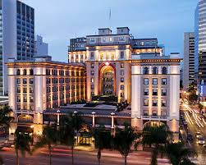

Downtown hotels are located at the center of the city in busy commercial and shopping districts. Everyone likes to stay downtown within easy reach of government and private office, shopping malls and entertainment centers. However, since the price of land is expensive, the rates of the hotels are high to enable the investor to get his return on investment. Investors, therefore, believe in constructing quality hotels to cater to a moneyed clientele, usually the business and corporate community. Up-market group may also find downtown hotels affordable. Usually downtown hotels will cater to guest on short visits to a maximum of one week stay. Premium brands of hotel chains and independent hotel of a very high quality are found in downtown locations. Naturally these hotels will also boast of leading restaurants, bars and night clubs. Downtown hotels in district that have day and night shopping, eateries and entertainment may cut their costs by having only bars and an all-purpose coffee shop, off the lobby. Guests can avail of a range of dining restaurants at a walking distance from the hotel. Nowadays, downtown hotels have purpose-built shopping malls with food courts and cineplexes along with their hotel for the benefit of their guests. Many have also added residential apartments and commercial office buildings to Ccreate a captive community within their precincts. Because of the paucity of space, downtown hotels are often tower blocks and skyscrapers, building upwards to create space and business opportunities.

* **Boutique Hotel**

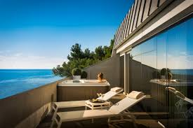

Boutique hotels is a term originating in North America to describe intimate, luxurious and even quirky hotel environments. They differentiate themselves from other branded ones by providing personalized facilities and services. A boutique hotel is a also known as “design hotel” or “Lifestyle Hotel”. The first boutique hotel may be credited to Morgan’s Hotel in Murray Hill by giving inspirational service and possibly a dedicated clientele.

* **Casino Hotel**

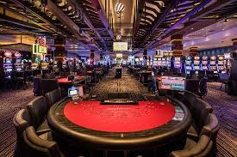

Casino hotel serve only one purpose to serve guests who want to gamble. Las Vegas in Nevada, U.S.A is the best example of the location of casino hotels, each more dramatic than the other. The essential features of casino hotels are gaming halls, sometimes the size of a football field, with all possible gambling games including banks of slot machines, Blackjack tables, Roulettes tables, etc. Each hotel outdoes each other in terms of features and entertainment. “New York, New York” boasts of a lobby that represents a New York street with street cafes, steam from sewers, street lamps leading to the gambling floor; MGM boasts of a sunken bar in the style of the Brazilian ran forest. “Treasure Island” has a sound and light show of a pirate ship being sunk; while “Bellagios” has dancing fountains that are unique sight. “Caesar’s Place” has all its staff dressed in Roman togas and boasts of amphitheater where famous modern day stars perform. Its bar is a Roman togas and boasts of amphitheaters where such funds casinos hotel are truly deluxe with the best facilities to meet practically every guest’s need. Most rooms are large and fitted with twin-queen-sized beds with bathrooms having separate bathing, shower and toilet areas. A bathroom would perhaps be the size of a guest room in a smaller property.

* **Convention Hotel**

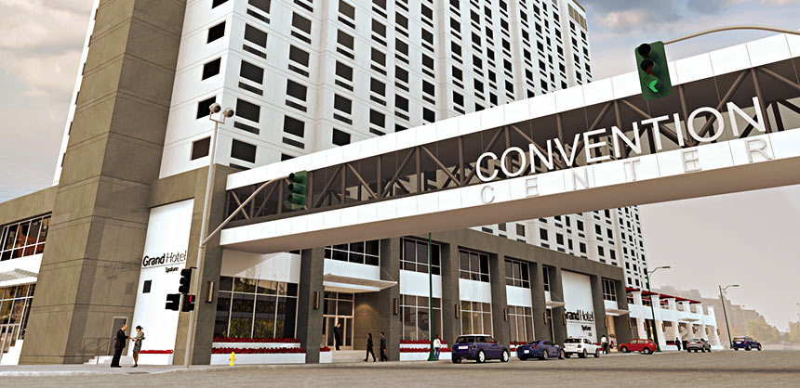

Convention hotels are specially designed for such purpose. They would have a large plenary hall to seat 2000 people or more, breakout meeting rooms for smaller groups, administrative office providing all the secretarial, office automation facilities, ample registration lobbies and large dining halls. The plenary hall and meeting rooms have state-of-the-art projection and public communications system required for convention. Most of the rooms will be twin-bedded to be used as single and twin rooms for delegates.

**Question 4**

**Explain the significant of Entertainment in this industry.**

* Sports and Gaming



In today’s society, the sports industry has evolved in many different ways including the marketing methods. Sports complexes are essentially large theatres of entertainment, which ought to be pleasant to visit, like a cinema, and at the same time also be social and architectural land marks in towns and cities. A sports complex is a closely knit well- balanced grouping of indoor and out-door games facilities offering a wide range of activities on a comparatively small land area. Sports and physical activities have been part of the natural endeavors of humans in earth. Technology evolves more and more. It becomes involved in daily life and in everything these days. In gaming industry also called Gambling that has become a major force in the hospitality. It has grown from a limited acceptance in the financial and public sector in Nevada to a recognized growth industry. Examples Casinos, Card Games, Charitable Games, Lottery-operated Games, Betting on greyhound and Horse Races and etc.

* Night club

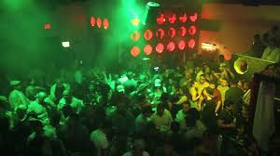

A nightclub also known as a discotheque, dance clubs, or simply a club or disco is an entertainment venue which usually operates late into the night. A nightclub is generally distinguished from bars, pubs or taverns by the inclusion of a dance floor and a DJ booth, where a DJ plays recorded music. Night clubs are primarily made to be a safe venue for people to come in and enjoy themselves together with their loved ones. Many young people find themselves in much stress after a busy week and they decide to attend night clubs so as to releasing tool for most young people and that becomes a great advantage. We all know, the night club is a place which causes the occurrence of social problems in society. Example

* Bars

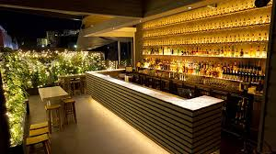

It is a place which serves soft and alcoholic beverages including draft and bottled beer, wine, spirits and cocktail. The back bar is a set of shelves of glasses and bottles behind the counters. Customers are served by barman at the raised counter. Customers sit on stools along the raised counter. Sometimes chairs and tables are also available. Food is also served in the bar. Some bars have entertainments on a stage, such as a live band, comedians, a floor show, etc. Hotel bars are hotel are called hotel lounges or long bar. Bar is the main entertainment industry in Singapore. Example Karaoke Bar, Salsa Bar, Dance Bar, Music Bar and etc.

* Cruise ship

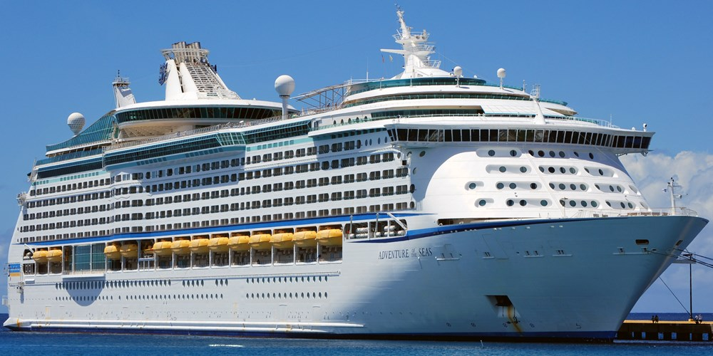

Cruise ship in this era serve as floating vacation liners. Ship have been used in travelling vacation liners throughout the ages. The decline of the popularity of water transport was brought about by the introduction of commercial airplanes. However, the cruise industry flourished again with the introduction of leisure travel. Cruise ship repositioned themselves by offering leisure activities to their passengers. A cruise ship is passenger used for pleasure voyages. Cruise ships are destinations in themselves with features and amenities comparable or superior to land-based resorts. Example Luxury cruise ship, Ocean cruise ship, Mega cruise ship, Adventure cruise ship and etc.

* Travel agency

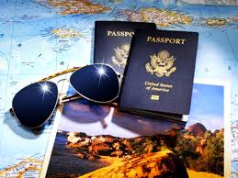

To travel is a natural desire of human beings. This comes from an urge to explore for better living conditions and to gain knowledge. The purpose of travel moved from pure survival need to wide reasons such as business, sports, exploration, etc. The hospitality industry will continue to prosper as long as globalization keeps on shrinking the distances thereby making access easier to all parts of the world. Travel and tourism is one of the largest industries in the world. The hospitality is a fascinating and ever-changing field. Many concepts and innovations developed by the hospitality industry have found their way to other field such as management, customer services, accounting, leadership skills and food and beverages operations. Example The group tour, Long term slow travel, Event travel and etc.

**Conclusion**

One of the major issues facing tourism and hospitality business is the speed of technological development. Digital technologies rapidly become obsolete which can result in records becoming inaccessible unless a strategy for migration and preservation is developed and adhered to.

An effectively implementation of technology is a key factor in ensuring the growth of tourism and hospitality business and the continuing value for future use. Hospitality and tourism careers are challenging and provide many opportunities to be creative to exceed guest expectations. The career provides an unlimited number of opportunities for persons who are willing to serve and make guest happy. After completion of the brochure, each learn will be assigned one component from question two. The team will write a one to two page paper on their component and present it to the class.

Five key dimensions of hospitality of hospitality organization as a commercial experience are identified; the host-guest relationship, generosity, theatre and performance, lots of little surprise and safety and security. To conclude, hospitality business must focus on the guest experience and stage memorable experience that stimulate all five senses. They must behave like boasts taking responsible for the experience and experience and creating lots of little surprise. They must appoint and develop their staff as performers and the cast in the experience. They must create a feeling of generosity, avoid parsimony, and not allow financial and operational control procedures to dominate the guest experience. Hospitality organizations that are able to capture this sense of theatre and generosity will gain competitive advantage by providing their guest with experiences that are personal, memorable and add value to their lives.

**References**

* [**https://www.beyond.com/tourism/defined**](https://www.beyond.com/tourism/defined)
* <https://www.beyond.com/tourism/defined>
* <http://www.besthospitalitydegrees.com/faq/what-exactly-is-the-hospitality-industry/>
* [**http://www.careerigniter.com/questions/what-are-the-different-types-of-tourism/**](http://www.careerigniter.com/questions/what-are-the-different-types-of-tourism/)
* [**http://www.careerigniter.com/questions/what-are-the-different-types-of-tourism/**](http://www.careerigniter.com/questions/what-are-the-different-types-of-tourism/)
* [**https://www.bookmyessay.com/tourism-and-hospitality-assignment/**](https://www.bookmyessay.com/tourism-and-hospitality-assignment/)
* [**https://www.makemyassignments.com/tourism-and-hospitality-assignment-help/**](https://www.makemyassignments.com/tourism-and-hospitality-assignment-help/)
* [**https://www.safarinow.com/cms/accommodation-types/irie.aspx**](https://www.safarinow.com/cms/accommodation-types/irie.aspx)
* [**https://www.vacayholics.com/type-of-tourism**](https://www.vacayholics.com/type-of-tourism)
* [**Http://www.solimarinternational.com/resources-page/blog/item/224-culture-tourism-four-example-of-how-it-works-for-destinations**](Http://www.solimarinternational.com/resources-page/blog/item/224-culture-tourism-four-example-of-how-it-works-for-destinations)

**Appendix**

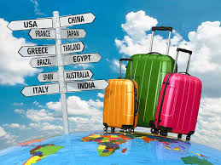 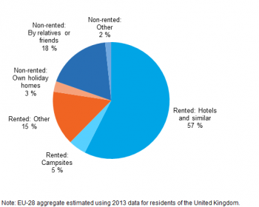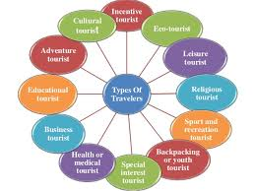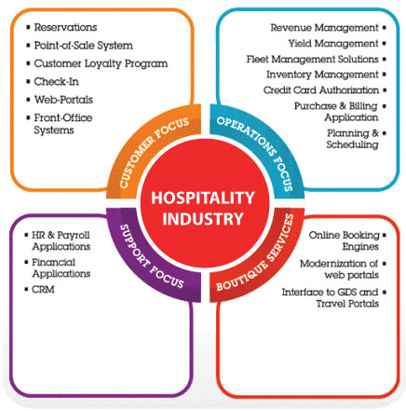

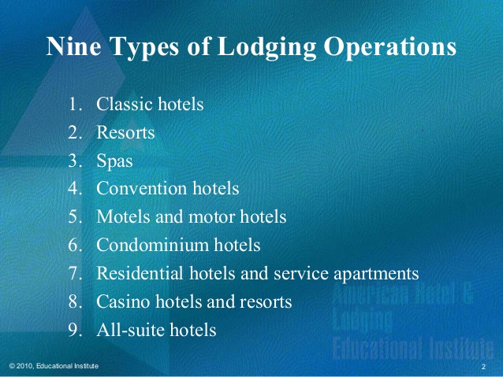 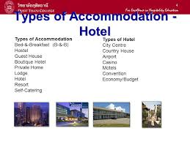

THE END